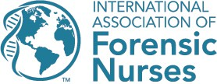

6755 Business Parkway, Suite 303, Elkridge, Maryland 21075

Certificate of Completion Approved Nursing Continuing Professional Development Activity

NAME:
Program Title: <Insert Program Name, if applicable> Adult/Adolescent Sexual Assault Nurse
Examiner Course

Program Type: Live Training

Program Location: Venue Name, Venue City, Venue State

Date:

Contact Hours: 40

The International Association of Forensic Nurses is accredited as a provider of nursing continuing professional development by the American Nurses Credentialing Center’s Commission on Accreditation.

Provider Number: P0372

International Association of Forensic Nurses 2024

