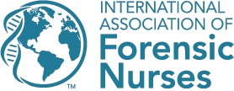

6755 Business Parkway, Suite 303, Elkridge, Maryland 21075

Certificate of Completion Approved Nursing Continuing Professional Development Activity

NAME:
Program Title: Adult/Adolescent SAFE Clinical Skills Lab
Program Type: Live Training

Program Location: Venue name, venue city, venue state

Date:

Contact Hours: 16

The International Association of Forensic Nurses is accredited as a provider of nursing continuing professional development by the American Nurses Credentialing Center’s Commission on Accreditation.

Provider Number: P0372

International Association of Forensic Nurses 2024

