Date of Strangulation: |  | Time of Strangulation:
Number of times strangled:
History (in patient’s own words):

Method/Manner of Strangulation: | ☐ One hand  ☐ Two hands  ☐ Chokehold  ☐ Approached from behind  ☐ Approached from the front  ☐ Ligature used | ☐ Multiple strangulation attempts  ☐ Jewelry on suspect’s hand/wrist  ☐ Jewelry on patient’s neck during strangulation  ☐ Other (comment)
During strangulation, did the patient note any of the following? | ☐ Loss of consciousness  ☐ Incontinence of stool  ☐ Being shaken  ☐ Feet were lifted off the ground | ☐ Incontinence of urine  ☐ Bleeding (comment)  ☐ Smothered in addition to being strangled  With what? ________________
Since the strangulation has the patient noted any of the following symptoms? | ☐ Coughing  ☐ Dysphagia  ☐ Lightheadedness  ☐ Nose Pain  ☐ Sore Throat  ☐ Combativeness/  irritability/restlessness  ☐ Loss of Memory (comment) | ☐ Drooling  ☐ Odynophagia  ☐ Neck Pain  ☐ Nausea  ☐ Crepitus/ subcutaneous emphysema  ☐ Voice changes (comment)  ☐ Bleeding (comment) | ☐ Dyspnea  ☐ Headache  ☐ Neck Swelling  ☐ Vomiting  ☐ Uncontrolled shaking  ☐ Vision changes (comment)  ☐ Weakness/numbness of extremities (comment)

Glascow Coma Scale
(Circle the appropriate score for each, complete the total at the bottom)

Eye Opening | Score
Spontaneous | 4
To speech | 3
To pain | 2
None | 1

Verbal Response | Score
Oriented | 5
Confused | 4
Inappropriate | 3
Incomprehensible | 2
None | 1

Motor Response | Score
Obeys Commands | 6
Localizes to pain | 5
Withdraws from pain | 4
Flexion to pain (decorticate) | 3
Extension to pain (decerebrate) | 2
None | 1
Total Score

Respiratory Assessment | O2 Saturation:  Time:___ Level:___  Time:___ Level:___ |  | Lung Sounds:
Cardiac Assessment | Heart Rate:  Time:___ Rate:___  Time:___ Rate:____ |  | Heart sounds: |  | Abnormal carotid pulse:  ☐ Yes (if yes, describe) ______________  ☐ No
Neurologic findings: | ☐ Ptosis  ☐ Paralysis  ☐ Facial Droop  ☐ Loss of sensation  ☐ Unilateral weakness  ☐ Other (describe):
Petechiae | ☐ Facial  ☐ External ears  ☐ Ear canal ☐ Left ☐ Right  ☐ Eyes  ☐ Conjunctival  ☐ Mouth  ☐ Neck  ☐ Other (describe):
Other | ☐ Tongue injury (see diagrams)  ☐ Oral cavity injury (see diagrams)  ☐ Subconjunctival hemorrhage (see diagrams)  ☐ Absence of normal crepitus felt during manipulation of cricoid cartilage  ☐ Visible injury (see diagrams)  ☐ Digital photographs taken
Patient Pregnancy Status | ☐ Yes  ☐ No  # of weeks___ | Fetal Heart Rate/NST: _______  Fetal Movement:______ |  | Pregnancy-related symptoms during or since the strangulation:

Cranial Nerve Assessment

CN I: Olfactory  Function: Convey sense of smell. | ☐Within Defined Limits ☐Exceptions to Within Defined Limits  Assessment: Test each nostril with substances of known odors.  Comments for Exceptions:
CN II: Optic  Function: Transmits visual information. | ☐ Within Defined Limits ☐ Exceptions to Within Defined Limits  Assessment: Test visual fields (outer, inner, right, left) of each eye.  Comments for Exceptions:
CN III: Oculomotor  Function: Coordinates eye movement. | ☐ Within Defined Limits ☐ Exceptions to Within Defined Limits  Assessment: Test the six cardinal positions of gaze.  Comments for Exceptions:
CN IV: Trochlear  Function: Coordinates eye movement. | ☐ Within Defined Limits ☐ Exceptions to Within Defined Limits  Assessment: Test the six cardinal positions of gaze.  Comments for Exceptions:
CN V: Trigeminal  Function: Provides sensation to the skin of the face and also controls the muscles of mastication. | ☐ Within Defined Limits ☐ Exceptions to Within Defined Limits  Assessment: Test sensation with a dull object in all areas of the face.  Comments for Exceptions:
CN VI: Abducens  Function: Coordinates eye movement. | ☐ Within Defined Limits ☐ Exceptions to Within Defined Limits  Assessment: Test the six cardinal positions of gaze.  Comments for Exceptions:

CN VII: Facial  Function: Coordinates facial movements and expression | ☐ Within Defined Limits ☐ Exceptions to Within Defined Limits  Assessment: Test facial symmetry with movement (smiling, raise eyebrows, etc.)  Comments for Exceptions:
CN VIII: Acoustic  Function: Coordinates hearing and balance. | ☐ Within Defined Limits ☐ Exceptions to Within Defined Limits  Assessment: Test hearing by rubbing fingers together by each ear. Assess balance in patient movements; note c/o dizziness.  Comments for Exceptions:
CN IX: Glossopharyngeal  Function: Provides sensory innervation to the oropharynx and back of the tongue. | ☐ Within Defined Limits ☐ Exceptions to Within Defined Limits  Assessment: Test gag reflex. Asses soft palate and uvula.  Comments for Exceptions:
CN X: Vagus  Function: Assists in coordinating pharyngeal muscles; serves as the major supply nerve to the recurrent laryngeal nerve. | ☐ Within Defined Limits ☐ Exceptions to Within Defined Limits  Assessment: Test ability to swallow. Listen for voice changes (note c/o voice changes, hoarseness).  Comments for Exceptions:
CN XI: Spinal Accessory  Function: Coordinates neck and shoulder movements. | ☐ Within Defined Limits ☐ Exceptions to Within Defined Limits  Assessment: Test movements by shrugging shoulders and turn head against resistance.  Comments for Exceptions:
CN XII: Hypoglossal  Function: Coordinates movement of the tongue | ☐ Within Defined Limits ☐ Exceptions to Within Defined Limits  Assessment: Test tongue symmetry  Comments for Exceptions:

Please indicate all injuries that were identified during the assessment on the body diagrams
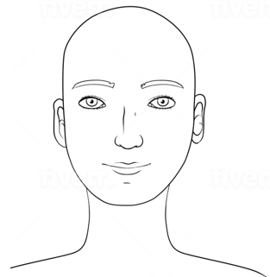 | Description
 | Description
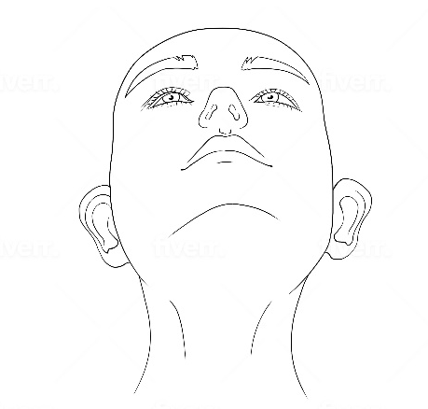 | Description

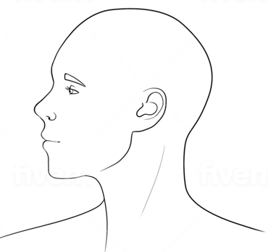 | Description
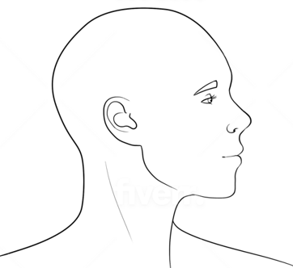 | Description
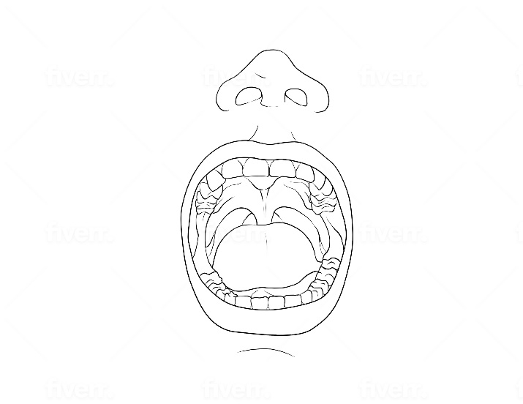 | Description

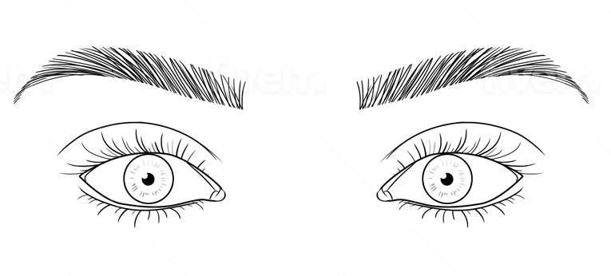 | Description
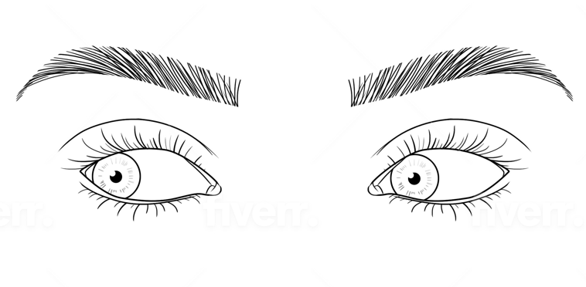 | Description
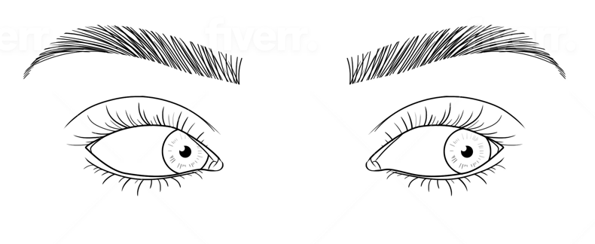 | Description
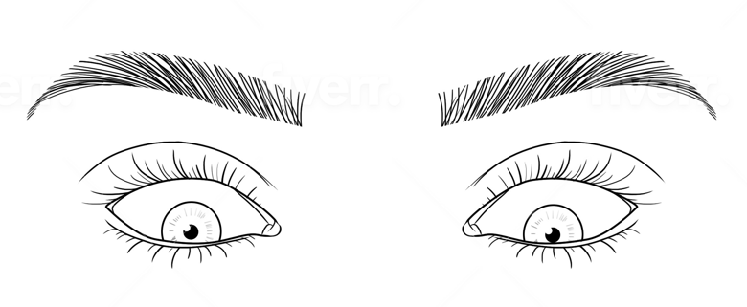 | Description
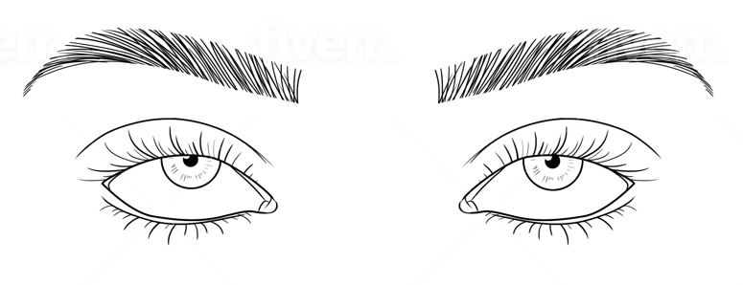 | Description

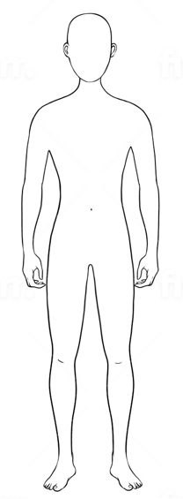 | Description
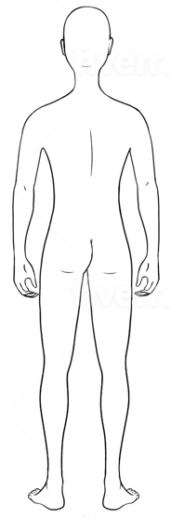 | Description
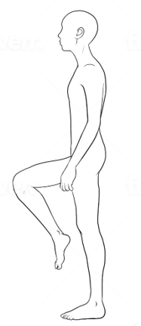 | Description
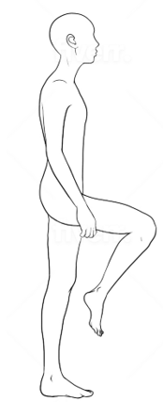 | Description

Photo-documentation of findings: ☐ Yes ☐ No

Notes

Forensic Nurse Examiner Signature
Date

